Python Practice Exercises

[1] Write Python codes that will print the following shapes.

A tree

/\
/ * \
/ *** \
/ *****\
|
|
|

A truck

_________________________________
| ______________________|
| |
| \_____________
| \______________
| ______ ______ \
| / \ / \ |
|________| |_____| |_____ |
\ / \ /
\______ / \_______/

A house

______________________________________________
/ \
/ \
/ \
/______________________________________________________\
| |
| ------------ ----------- |
| | | | | |
| | | |______| |
| | | |
| ____________|_______|________________________|

[2] Write Python code for the following Invoice Program

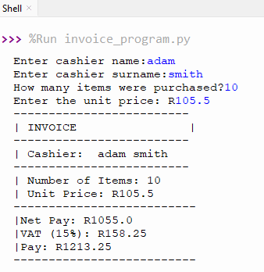

[3] Basic Calculator with Options
Create a basic calculator with a mini menu to perform addition, subtraction, division or multiplication based on the user choice. The program should also have an exit option.
See the screenshot below:

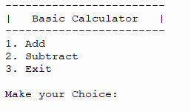
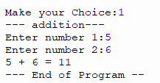
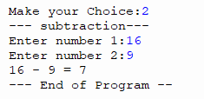
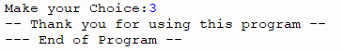

[4] Basic Calculator
In our previous basic calculator implementation, the program will terminate after performing a single calculation (addition/subtraction) and will need to be re-run to perform any other calculation. Make using of loops, we can create a basic calculator that runs indefinitely, going back to the main menu until the exit choice is selected.
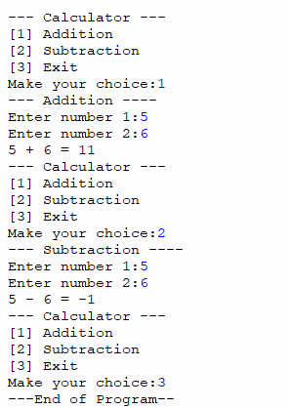

[5] – Create a Python program that checks whether a number is odd or even. Hint: %
[6] – Create a Python program that checks whether a number is prime or not prime.

[7] – Using Loops Only, Write Python codes that will print the following shapes.
Section A
Enter the number of stars: 6
*
**
***
****
*****
******

Section B
Enter the number of stars: 6
******
*****
****
***
**
*

Section C
Enter the number of stars: 6
*
***
*****
*******
*********
***********

Case Study 1 – SA ID verification App
South African ID Numbers are unique IDs that Home affairs attribute to every South African citizen. These ID numbers are 13-digit sequences that embed basic ID holder information (i.e., birth date, gender) as well as unique sequences that guarantee the authenticity of the ID.
You are required to create a Basic Java Application that requests the user to enter his/her South African ID. Upon submission of the user ID, the Java application should first verify if the ID is valid or not. An incorrect ID message should be displayed on the screen if the ID is fake looping the application back to the main menu.
Upon submission of a correct ID number, the program should display, the person's date of birth, gender, and status that specifies whether the person is a permanent resident in SA or a South African citizen.
The following are the criteria for South African ID numbers:
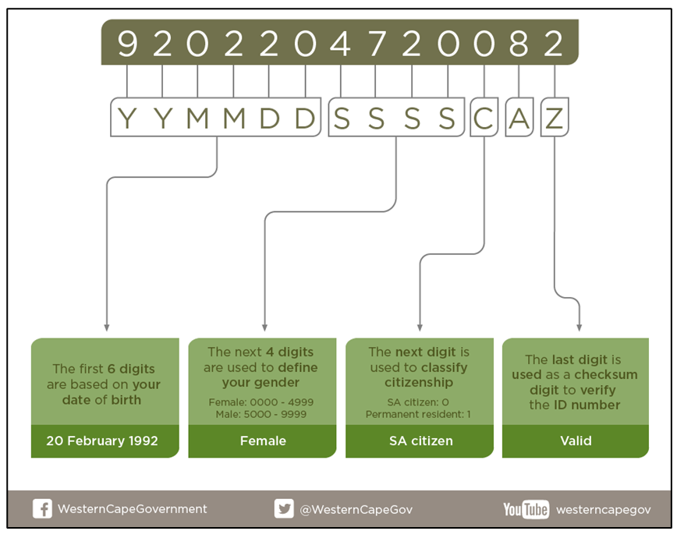
[Source: www.westerncape.gov.za (2022)]
The last digit (Z) is a checksum digit – used to check that the number sequence is accurate using a set formula called the Luhn algorithm. Research on the algorithm.
[A] can be any number but usually an 8.
Your program should comprise of a main menu that looks as follows:
